Umbrella studies
Biking Under the Influence
Derek rode his bike to work every day, mainly for the exercise. One Friday afternoon after a difficult project was completed, he and his coworkers decided a happy hour was in order. After a few drinks, he decided he better ride home before he lost the daylight. As he was cycling out of town, he ran a red light in front of Heather.
Swerving to avoid him, she collided with another car and sustained a variety of complex injuries, which resulted in decreased mobility and motor function. She was unable to return to work as a university mathematics professor for several months.
Heather's medical bills quickly exhausted the minimum coverage offered by Derek's renters insurance, so she had no choice but to sue him for reimbursement, incurring legal fees paid in advance, out of her own pocket.
Because Derek didn't have significant assets, he declared bankruptcy, putting Heather back to square one. Burdened by debt, unable to work and without compensation for lost wages, she too was forced to declare bankruptcy.
Rewriting the story
If Heather had a personal umbrella with $1 Million excess UM/UIM, it would have covered the gap left by the underlying policies to take care of her legal fees, lost wages and medical bills.
Claim: $925,000

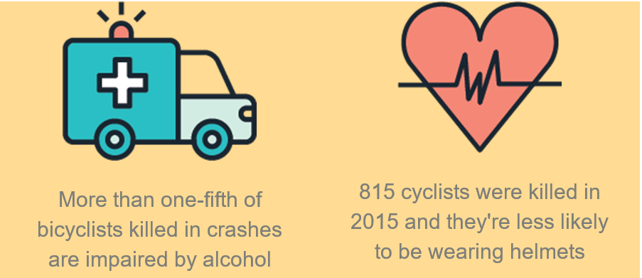
This is just an example of graphic. You can update/change

Parents Liable for Halloween Prank
Zack found leftover Fourth of July fireworks in the garage just in time for Halloween. He couldn’t wait to tell his friend, Fletcher. While the parents were soundly asleep, the pair snuck out to give them a try. A bottle rocket zoomed off-course and landed underneath their neighbor’s car, catching it — and their neighbor’s home — on fire. Because of “vicarious parental liability,” Zack’s parents were on the hook for his actions, even though they weren’t present and didn’t know what he was up to.
Rewriting the story
If Zack’s parents had a personal umbrella with $1 Million, it would have covered the gap left by the underlying policies to take care of their legal fees and property damage.
Claim: $620,000
{insert graphic}

One Quick Text
Ashley and her BFF were heading out to meet their college friends for dinner, but they couldn’t remember what time they were supposed to meet. Ashley sent a quick text to check. With her eyes on her phone instead of the road, Ashley didn’t see the bicyclists in the crosswalk until it was too late. Both cyclists sustained serious injuries requiring hospitalization and rehabilitation. After Ashley’s auto liability limits were exhausted, she was held personally responsible for their medical bills.
Rewriting the story
If Ashley had a personal umbrella with $1 Million, it would have covered the gap left by her underlying auto policy to take care of her legal fees and the cyclist’s lost wages and medical bills.
Claim: $625,000
{insert graphic}

